# 

## 

## 

## 

## Faculty of Computing

**Class: BSE-Section A&B 2025  
Course: Applications of ICT**

# **Lab 04: Exploring Networks with Wireshark**

**Date: 29, Sept 2025**

**Student Name: Amna Mirza**

**LMS ID: 555626**

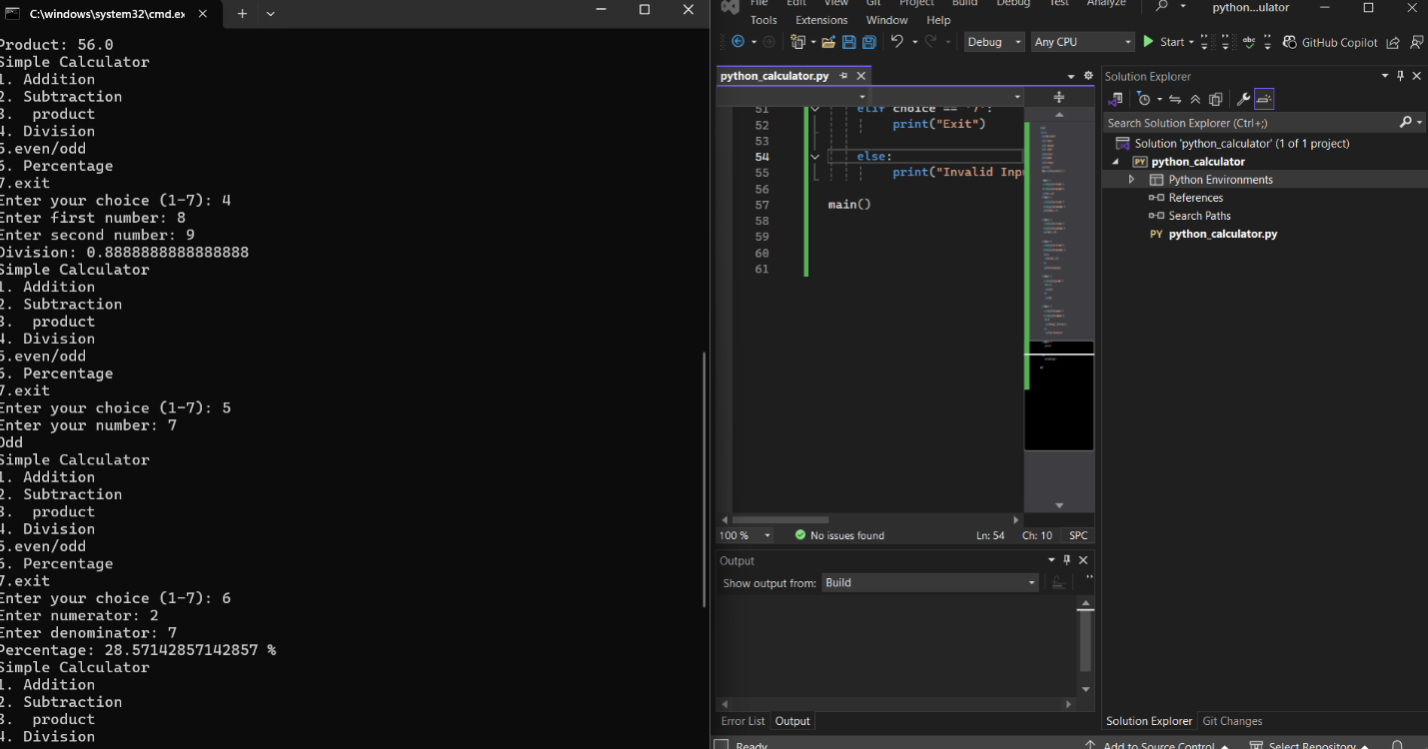

## 

## 

## 

## 

## 

## Roles

* **Person A [Name] = Packet Catcher + Navigator** (runs Wireshark, follows steps).
* **Person B [Name] = Analyst + Reporter** (examines details, records answers).

## Task 1: task title here

Enter your answers here

## 